TEMP MEMS

Chris C. Coleman

The University of Kansas Hospital

Revision History
Author | Date | Revision
C. C. Coleman | 2/8/2014 | Initial Release

Table of Contents
Vision Statement 4
Requirements 5
Step #1: Identify Categories of Users 5
Step #2: Create Actor-Goal List 5
Step #3: Identify User Stories 6
Sprints………………………………………………………………………………………………………………7
Sprint #1…………………………………………………………………………………………………………………………………….7
Sprint #2…………………………………………………………………………………………………………………………………….8

Vision Statement

With the new requirements of hospitals and healthcare providers to keep track of all medical devices in use in their facilities comes a need to efficiently and effectively note the equipment that is constantly coming and going. The persons responsible for tracking this equipment need a simple and portable application to inventory the equipment that is coming into the building and be able to track when it is supposed to leave along with when it actually leaves. An application that allows users to enter temporary equipment into a database separate from the permanent equipment may lead to less redundancy of administrative data entry while giving those tasked with reporting temporary equipment a place to quickly retrieve the information they desire.
TEMP MEMS short for temporary medical equipment management system will be a product that will aide in the challenges listed above. Armed with this application on any android based device the person responsible for gathering the pertinent information involved with an incoming inspection will know just what he/she needs to get. Once they’ve got the data and attached a control number sticker the data will be stored exactly where it needs to be in order to be referenced later. The database of equipment in use could be accessible to anyone running the app in order to report on what is and is not in house. Once the equipment is removed from the facility it will remain in the database but given a removal date and have that control number physically removed. If that same piece of equipment comes back it will need that crucial incoming inspection to re-verify the data and attach a new control number sticker.
It would be desirable for the application to run simple reports like the equipment that is scheduled for removal on any particular day or list equipment that has not been removed but is past its estimated removal date. Being able to track equipment by the area it is used in would be helpful as well. Good to know if the equipment was intended for the liver transplant operating room or over in the heart bypass recovery area when looking for it to get it removed. The option to send an email to a specified address at the point of inspection and point of removal with specific data would provide a beneficial backup as well.
TEMP MEMS will provide a simple and effective solution for tracking equipment and bring peace of mind to those responsible for reporting on this growing aspect of equipment management.

Requirements
This application will be used by two types of users, the people entering the data and those reviewing the data. Each user should have an idea of both how to enter and review but will be more specialized in their particular tasks.
The application will prompt the person entering the necessary data and allow for extra notes. The person intended to enter this information should have a basic knowledge of a variety of medical equipment and how it is used, someone like a biomedical equipment technician or BMET. The inspection task should be clear and easy with little ambiguity and not allow the user to complete an entry unless all necessary data is entered. At which point an email could be sent with the information collected and the data is entered into a specified database. A picture of the equipment itself and possibly of its data plate may make it easier to identify the equipment by any viewer of the data.
Once the database has some entries someone like a biomedical engineering manager or materials management person, with similar knowledge of the equipment as the BMET, should be able to run simple reports pertaining from that data. Reports like what equipment is in the facility and possibly where it is being used. Other reports showing what equipment is in use past its estimated removal date or what has been reported removed should be available through the app. They could be the ones receiving emails as well. This could be a function of the app to enter email addresses for each inspection and removal.

Actor | Goal
BMET | Complete incoming inspection
 | Gather and enter necessary information along with pics
 | Complete removal
 | Enter the removal date to change the status of the equipment
 | Review all entries
Manager | Lookup a particular piece of equipment
 | Use a serial number or control number to search equipment
 | Run an in use report
 | Run a device past removal date report

As a BMET, I want to be able to enter the specifics of the equipment I am checking in
Estimated Effort: 3 points

As a manager, I want to be able to see what equipment is in use in the hospital
Estimated Effort: 5 points

As a BMET, I want to open an existing piece of equipment and enter its removal date
Estimated Effort: 3 points

As a manager, I want to be able to see what equipment has left the hospital
Estimated Effort: 4 points

Product Backlog

Story ID | Story | Story Points | Priority | Status
S1 | Allow user to enter information | 3 | 1
S2 | Allow manager to report devices in use | 5 | 3
S3 | Allow equipment records to be updated with removal date | 2 | 2
S4

Sprint #1
In the first sprint the app needs to be created with multiple pages for adding and viewing the equipment along with a Splash screen and upload it to GitHub

Sprint Backlog
Story ID | Story / Task | Estimated  Hours | Actual  Hours
S1 | Create Android Studio project | .5 | 2
 | Create logo | .5 | 2
 | Add buttons that open new activity screens | 1 | 2
 | Create a Splash Screen | .5 | 2
 | Upload project to GitHub | 1 | 4

Sprint Review
In the first sprint has the framework of the app in place with a logo, splash screen and activity screens activated by buttons on the main activity. I ran into an issue with the splash screen activity changing the icon and name of the activity once implemented. The code can be viewed at https://github.com/cccyt3/TEMP_MEMS.git

Screen shots can be viewed on the next page

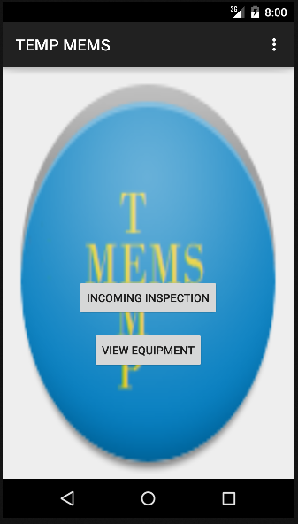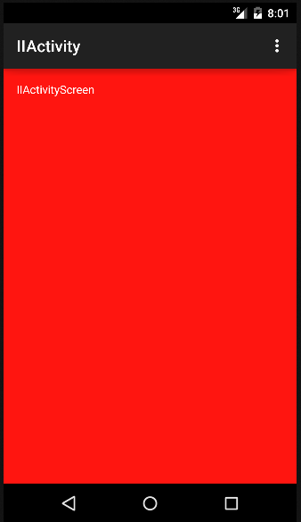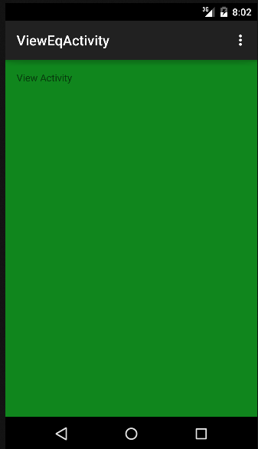

Sprint #2
The second sprint will build more functionality into the app. The ability to enter equipment information into a list a view it in a separate activity.
Sprint Backlog
Story ID | Story / Task | Estimated  Hours | Actual  Hours
S2 | Add text boxes for input of incoming inspection | 2 | 2
 | Store information of equipment into a file for DB or email | 4 | 0
 | Correct the icon and app label | 1 | .5
 | Work on the overall look of the app | 4 | 0

Sprint Review
In this second iteration I was able to implement the list view aspect of my app. There is still work to be done to the individual items that are put into the list and I must do more research to properly implement the database aspect of the app.

Screen shots of the list view can be viewed on the next page
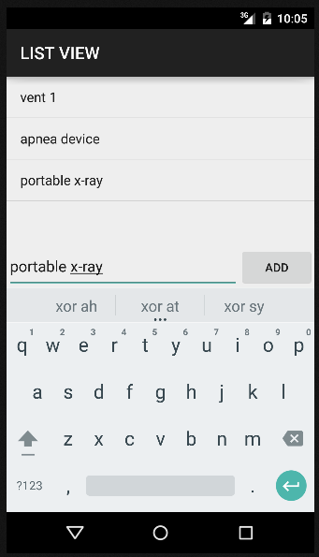

Sprint #3
The third sprint will build the database aspects into the app. Taking the information of the list view and entering it into the database.
Sprint Backlog
Story ID | Story / Task | Estimated  Hours | Actual  Hours
S3 | Create Database | 4 | 4
 | Store information into database | 4 | 2
 | View the database with SQLite | 1 | 1
 | Ponder the design of the app | 4 | 3

Sprint Review
The third iteration of this app was hindered by my professional commitments. I did not have the time I needed to complete the iteration in the timeframe for the course. I did get a database implemented and viewed it with SQLite studio but it needs to be customized for my application. The new code has been uploaded to GitHub for your review.

Screen shot of the database pulled from my emulator running my Temp Mems app
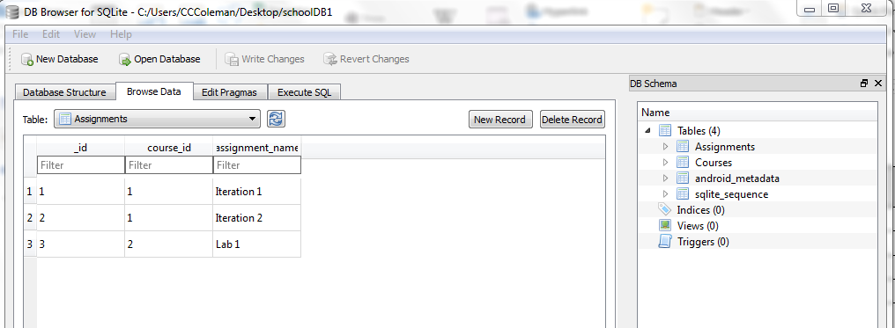

Sprint #4
The forth sprint focused on assertions and exceptions.
Sprint Backlog
Story ID | Story / Task | Estimated  Hours | Actual  Hours
S4 | Assert serial numbers entered as 6 digit integers | 2 | 3
 | Exception thrown if database doesn’t open properly | 1 | 1
Sprint Review
This iteration was important to prevent hard to detect errors in this app. The code was pretty simple and can be found in the CourseGateway class and the Spec entry class. The new code has been uploaded to GitHub for your review.

